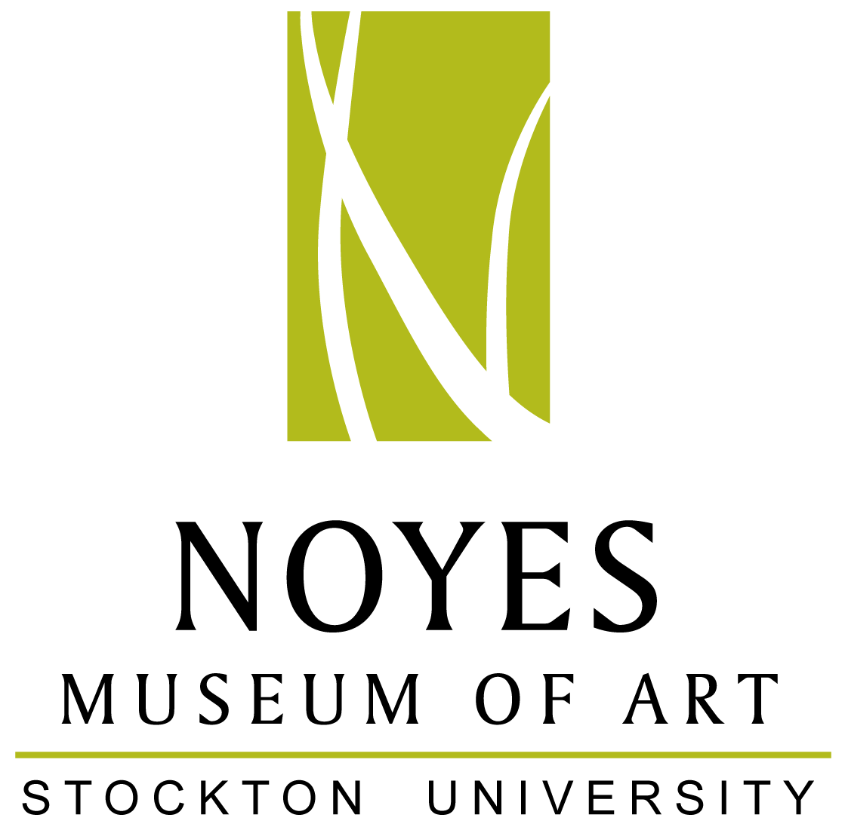

The Noyes Museum of Art of Stockton University
Noyes Gallery: Kramer Hall, 30 Front St., Hammonton, NJ 08037 • (609) 626-3420 • www.noyesmuseum.org
Noyes Shop: 5 Second Street, Hammonton, NJ 08037 • (609) 561-8006
Arts Garage: 2200 Fairmount Ave., Atlantic City, NJ 08401 • (609) 626-3805 • artsgarageac.com

Press Release For Immediate Release
Contact: Saskia Schmidt January 17, 2017
Noyes Museum Director of Education
Hammonton, N.J. 08205
education@noyesmuseum.org
(609) 626-3420

Noyes Museum of Art of Stockton University Announces
Winter Events

ARTS GARAGE, ATLANTIC CITY:
ATLANTIC CITY, NJ - The Noyes Arts Garage of Stockton University is proud to celebrate the opening of That Shadow My Likeness: Photography by Glynnis Reed, on view from January 12 - April 2, 2017. Visit the galleries to see: That Shadow My Likeness: Photography by Glynnis Reed (The Noyes Museum Gallery II); A Dark Wood (The Noyes Museum Gallery I); The Noyes Permanent Collection: Paintings by Hulda Robbins (AC Art Gallery); Jicheng Yao (Oriental Gallery); and The Heart of Surfing (Osprey Gallery).
In the exhibition That Shadow My Likeness, on exhibit from January 12 - April 2, 2017, artist Glynnis Reed presents women in harmony with and in contrast to the natural landscape. This juxtaposition highlights questions surrounding the constructs of black female beauty, femininity, and identity. Often invisible - due to their gender, race, beauty, and youth, they are in turn accepted and rejected by the “mythic norm” of American culture. “Likeness,” or persona, is a key dimension of the work whose titles are borrowed from poems by Walt Whitman.
A Panel Discussion in conjunction with the exhibition That Shadow My Likeness is planned for Sunday, Mar. 26, 1 - 2:30 p.m. Wendel White, Distinguished Professor of Art, and Dr. Christina Jackson, Assistant Professor of Sociology, both of Stockton University; and artist Glynnis Reed will discuss issues of race, gender, and identity within the context of the natural landscape, as explored in Reed’s exhibition. The panelists will look at how two parks in the Southern California and Southern New Jersey landscapes serve as evocative settings for the protagonists in the series. The dialogue will also explore the relationship of Reed’s work to the legacy of representations of identity by African American photographers.
A Dark Wood, on exhibit from January 13 - April 23, 2017, explores the theme of being lost in the darkness of our fears, doubts and negativity. Dante Alighieri, the 14th century Italian poet, began The Divine
-more-
-continued from page 1-
Comedy with a character who has lost his way in "a dark wood.” It is a metaphor not only for a crisis of faith, but a crisis of humanity. He has lost his spiritual compass, even how to be with and treat other people. His character must survey the punishments of Dante’s taxonomy of evil before he is able to find a way to even a dim light of hope. There are many aspects of the dark wood and the artists presented in this exhibition interpret the richness of the concept through a range of media and methods.
The Noyes Permanent Collection: Paintings by Hulda Robbins exhibition is on view at the Arts Garage in the A.C. Gallery from Dec. 7, 2016 through Feb. 12, 2017. Robbins, a prolific printmaker, produced serigraphs, lithographs and woodcut prints, as well as oil paintings throughout the 1940s, 50s and the early 60s.The Jersey Shore provided many of the subjects for her large expressive oils.
The Heart of Surfing Exhibition, in the Osprey Gallery at the Arts Garage, is on view from Dec. 7, 2016 through Feb. 12, 2017. Heart of Surfing is a non-profit organization that began in 2014 as a surfing program for families with autism. They quickly expanded to include pre- and post- season skateboarding. Today they offer a variety of indoor and outdoor recreation activities for special needs individuals ages 5 to 95 and their families. This exhibition highlights the art activities of Heart of Surfing. Purchases or donations go to supplies and activities for the children. http://heartofsurfing.com/
For more information call (609) 626-3805 or visit artsgarageac.com.
NOYES GALLERY AT STOCKTON’S KRAMER HALL, HAMMONTON
HAMMONTON, N.J. - During Hammonton’s Third Thursday event on Jan. 19, The Noyes Gallery at Stockton’s Kramer Hall will stay open late from 6 - 8 p.m. Be sure to visit the RAW 2017: Juried Photography Exhibition, on view from Jan. 19 - May 1, 2017. RAW 2017 is a photography competition in which the top forty images by twenty photographers were selected by jury for an exhibition at the Noyes Museum Gallery. The Noyes Gallery is free and open to the public.
The Noyes Museum Shop in Hammonton is also open late on Third Thursday, Jan. 19 from 6 – 9 p.m. for She, a ladies evening out, spotlighting women. Come alone or bring your friends to the Noyes Shop and create decorative candle holders out of wine glasses, a simple and fun DIY craft. The Noyes Shop staff will provide instructions on how to make your own hand-painted candle holder. The craft is free and no registration is required. Check out the rest of Downtown Hammonton for shopping, food, drinks, art, and other great offerings!
For Hammonton’s Third Thursday on Feb. 16, The Noyes Gallery at Kramer Hall will host a free reception celebrating the opening of the RAW 2017: Juried Photography Exhibition. This exhibition is on view from Jan. 19 - May 1, 2017. Meet the artists and enjoy refreshments, wine, and cheese from 6- 8 p.m. The RAW 2017 exhibition showcases the work of 20 talented photographers selected by jury from throughout the state of New Jersey. Jurors were Wendel White, Distinguished Professor of Art at Stockton University, and Saskia Schmidt, Director of Education at The Noyes Museum of Art of Stockton University.
RAW 2017 - Photographers included in this exhibition: Rachel Adams, Kaltoum Alibrahimi, Susan Allen, Valerie Bowe, John Chesebro, Jeanette DePiero, Elizabeth Jackson, Kate Jeschon, Mae Kellert, G. Scott Kern, Wayne Klaw, Dave Magyar, Abigail Orme, Yelena Strokin, Kenneth B. Thompson, Julian Weitzenfeld, Gary Wiesner, Lindsay Wray, and Liz Wuillermin.
-more-

-continued from page 2-

The Noyes Museum of Art of Stockton University is proud to present a New Teacher's Workshop - The Therapeutic Power of Art: Motivation, Pride, Success on Tues., Mar. 14, 2017 from 9 a.m. - 2:30 p.m., at Stockton's Kramer Hall in Hammonton.
The teacher’s workshop presenter is Abbie Kasoff, CEO and Founder, Say It With Clay. This is an intensive and information-rich workshop for art educators and artists. Kasoff, with a background in social work and years of experience using art as a therapeutic tool, will discuss her knowledge, experiences, and projects working with children. The theme of the workshop aligns with the mission of Say It With Clay: create pride, build patience, improve social skills, and enhance fine motor skills through the therapeutic power of clay. Take away a variety of methods for using art to promote motivation, pride, and success in the classroom. Workshop participants will work on their own projects and be guided in the process by the instructor. The cost is $55 - or 4 ETTC hours (www.ettc.net ). Participants will earn 5 professional development hours. The registration deadline is Mar. 14, 2017. Visit www.noyesmuseum.org for more information and a registration form.
Questions? Contact Saskia Schmidt, Director of Education: education@noyesmuseum.org or call (609) 652-1776 x5200
Current Exhibitions at the Noyes Arts Garage of Stockton University - Atlantic City:
- The Noyes/Stockton Gallery I:
A Dark Wood Jan. 19 – Apr. 23, 2017
- The Noyes/Stockton Gallery II:
That Shadow My Likeness: Photography by Glynnis Reed Jan. 12 – Apr. 2, 2017
- The Atlantic City Gallery:
The Noyes Permanent Collection: Paintings by Hulda Robbins Dec. 7, 2016 - Feb. 12, 2017
- The Osprey Gallery:
The Heart of Surfing Exhibition Dec. 7, 2016 - Feb. 12, 2017

Upcoming Events at the Noyes Arts Garage of Stockton University - Atlantic City:
Poetry Night, 7 – 9:30 p.m. Jan. 25
Story Slam, 7 – 9:30 p.m. Jan. 27
"Hamiltunes" Feb. 4
At the Shore Wine Tasting Art Show Feb. 8
Second Friday (The public is welcome: 2nd Friday of Every Month) Feb. 10
Opening Reception: A Dark Wood (on 2nd Friday, 6-8pm) Feb. 10
Pecha Kucha Event, 3 – 4:30 p.m. Feb. 11
Watercolor Class with Stephanie Segal Miller, 2 – 4:30 p.m. Feb. 12

-more-

-continued from page 3-
Current Exhibitions of the Noyes Museum of Art of Stockton University, Kramer Hall - Hammonton:
- Noyes Gallery at Stockton’s Kramer Hall, Hammonton:
RAW 2017: Juried Photography Exhibition Jan. 19 - May 1, 2017

Current Exhibitions of the Noyes Gallery at Stockton’s Seaview Resort - Galloway:
- Noyes Gallery at Stockton’s Seaview Resort in Galloway Township:
Pulp: Works from the Noyes Permanent Collection Sept. 1, 2016 – Apr. 9, 2017
Beyond All Repair: Prints and Photographs Jan. 13 – Apr. 9, 2017

Upcoming Events at the Noyes Museum of Art of Stockton University, Kramer Hall - Hammonton:
- Third Thursday (The public is welcome: 3rd Thursday of Every Month) Jan. 19
- Third Thursday (The public is welcome: 3rd Thursday of Every Month) Feb. 16
- Opening Reception:
RAW 2017: Juried Photography Exhibition (on 3rd Thursday, 6-8pm) Feb. 16
- Teacher’s Workshop, 9 – 2:30 p.m. Mar. 14

About:
The Noyes Museum of Art was founded in Oceanville, NJ, in 1983 to collect, preserve, and exhibit American fine and folk art, with an emphasis on New Jersey artists and folk art forms. Today, the Noyes Museum’s exhibitions reflect the area’s cultural heritage, while also presenting significant artwork by regional and national artists working in a variety of media. The Noyes has expanded to include galleries in Hammonton, Atlantic City, and at Seaview Resort in Galloway. The Noyes Shop: Hammonton opened in 2008 and specializes in custom framing. The Noyes Gallery at Kramer Hall in Hammonton is the newest addition to the vibrant Arts District in Downtown Hammonton, and The Noyes Museum’s satellite exhibition spaces. It is located at 30 Front Street, Hammonton, NJ 08037. In February 2010, The Noyes Museum of Art formed a partnership with Stockton College (now Stockton University) to form The Noyes Museum of Art of Stockton University. Through a 2013 partnership with the CRDA, The Noyes Museum opened The Noyes Arts Garage of Stockton University, a unique multi-use arts and retail space at 2200 Fairmount Avenue in Atlantic City. # # #
Captions:
- Glynnis Reed, Survival, Photograph - That Shadow My Likeness: Photography by Glynnis Reed Exhibition (Arts Garage)
- John Rappleye, Fractured Vision, 2015, Acrylic and spray paint on paper - A Dark Wood Exhibition (Arts Garage)
- Abigail Orme, 180 Distortion and Mysterium 3, Photograph - RAW 2017: Juried Photography Exhibition (Stockton’s Kramer Hall)

