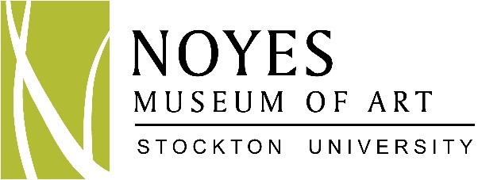
Summer Art Camps 2017

Three weeks of fun-filled and creative art projects to make your summer a blast!
Registration required • Limited space available

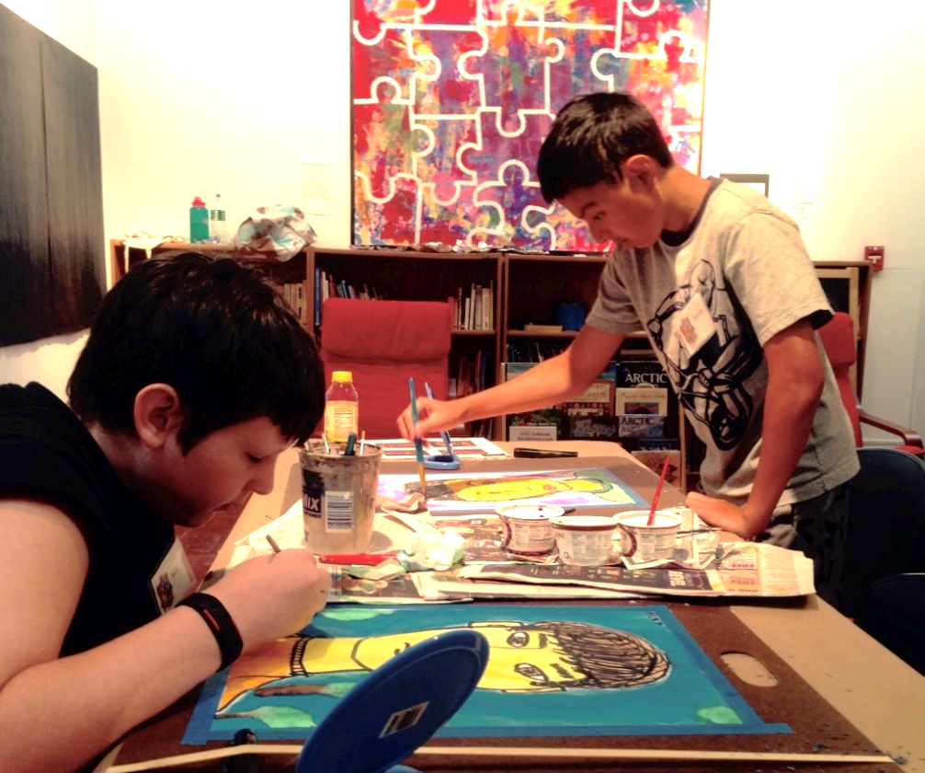

July 10 – 28 • 9:00am - 12:00pm • Ages 6 – 13

- Colors of Summer Art Camp • 7/10 – 7/14 • Ages 6-13 • Registration deadline: 7/1

Creativity truly explodes when you have a choice of colorful art materials and mediums at your fingertips! Create in the medium you choose, with guidance, from a variety of unique and exciting art projects: glue and pastel art; "stained glass" drawings; wildlife photography-inspired collages; drawing and watercolors; acrylic painting; clay and more! Instructor: Stephanie Polinski

- Pirates Art Camp • 7/17 - 7/21 • Ages 6-13 • Registration deadline: 7/8

Avast, me hearties! The good ship Noyes is about to sail. As one of our pirate crew, you’ll learn about the pirate life and what we do to keep busy on long voyages. We’ll be craftin’ a treasure chest and map, a Jolly Roger flag, scrimshaw, signal flags, gold doubloons, and much more. Create a pirate avatar and maintain a captain’s log. Join us, if ye dare… Instructor: Trish Schuster

- Famous Artists Camp • 7/24 - 7/28 • Ages 6-13 • Registration deadline: 7/15

Learn about the styles, art materials, and techniques used by famous artists. Experiment and explore many different mediums while discussing works of art by Georgia O'Keeffe, Picasso, Seurat, Van Gogh, and Andy Warhol. Have fun creating drawings, paintings, sculptures, and prints using materials such as charcoal, clay, recycled objects, and acrylic and watercolor paints. Instructor: Christine O'Brien

Noyes Art Camps will take place in the Stockton University Art Gallery,
Stockton University, 101 Vera King Farris Drive, Galloway, NJ 08205

www.noyesmuseum.org • (609) 626-3420
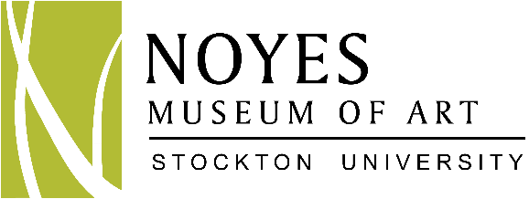

REGISTRATION FORM: NOYES SUMMER ART CAMPS

ART CAMP FEES:

ONE WEEK OF CAMP: Non-member: $190 Member: $165 (With Family Membership)
EARLY BIRD DISCOUNT: Register by May 10th to receive $10 off for each week of camp
MULTIPLE CAMP DISCOUNT: Receive $10 off each additional camp (Multiple discounts apply to 1 child)

Camp includes 1 Noyes t-shirt per camper and art supplies

Child’s Name: ___________________________________________________ Date of birth: ____________________

Age: _________ T-shirt size: __________

Names of parent(s) or guardian(s): __________________________________________________________________

Name(s) of pick-up person(s): ______________________________________________________________________

Address: ________________________________________________________________________________________

Home phone: _____________________________________Cell phone(s):___________________________________

E-mail: _________________________________________________________________________________________

Check off the sessions your child will be attending: FEE:
- ____ Colors of Summer Art Camp • 7/10 – 7/14 • Ages 6-13 • Registration deadline: 7/1 ______

- ____ Pirates Art Camp • 7/17 - 7/21 • Ages 6-13 • Registration deadline: 7/8 ______
- ____ Famous Artists Camp • 7/24 - 7/28 • Ages 6-13 • Registration deadline: 7/15 ______

____ Total # of Camps

Purchase Noyes Museum Family Membership ($65): Yes ____ No ____

TOTAL AMOUNT: $ ______

V ____ MC ____ AE ____ Credit Card #: _______________________________________ Exp. Date: _______

Signature of Cardholder: _____________________________________________________________________

Check# ________ Amount: _________Please make checks payable to: The Noyes Museum of Art

Scan and email to: education@noyesmuseum.org or mail to:
Attn.: Summer Art Camp
The Noyes Museum of Art of Stockton University
Kramer Hall
30 Front Street
Hammonton, NJ 08037

Withdrawal & refund policy: Students withdrawing 3 weeks or more in advance of a camp session will receive a full refund minus 10%. Any cancellations between 1 to 3 weeks before the start of a camp will receive a refund of 50% of the tuition costs. Withdrawals 1 week or less in advance will receive no refund. If the Noyes cancels a camp, a full refund will be given, otherwise, there will be no refund after a camp begins.

www.noyesmuseum.org • (609) 626-3420

INFORMATION FOR MEDICAL EMERGENCY

NAME OF CAMPER: __________________________________ DATE: _____________

Emergency Contact #1:

NAME:__________________________________________RELATION:___________________

PHONE/HOME:__________________ WORK:___________________ CELL:____________________

Emergency Contact #2:

NAME: _________________________________________ RELATION: ___________________

PHONE/HOME: _________________ WORK: __________________ CELL: _____________________

Student health information:

PHYSICIAN NAME: _________________________________PHONE:___________________________

ALLERGIES: ________________________________________________________________________

MEDICATIONS: ______________________________________________________________________

SPECIAL NEEDS:_____________________________________________________________________

Release and Consent:

I hereby agree to indemnify and hold harmless The Noyes Museum of Art of Stockton University and its employees against any and all claims for personal injuries or damages of any kind arising from participation in The Noyes Museum’s programs. Further, I authorize The Noyes Museum’s staff and faculty to seek emergency medical help if this becomes necessary. I realize that every effort will be made by The Noyes Museum’s staff to contact the emergency contact person in the event of a medical emergency, and I agree to indemnify and hold
harmless The Noyes Museum’s personnel in seeking medical care for my child.

______ (initial) I understand that The Noyes Museum may be taking photographs during the session for promotional use that may include my child.

Parent/Guardian Signature: _____________________________________ Date: ____________

www.noyesmuseum.org • (609) 626-3420

