Education Guide

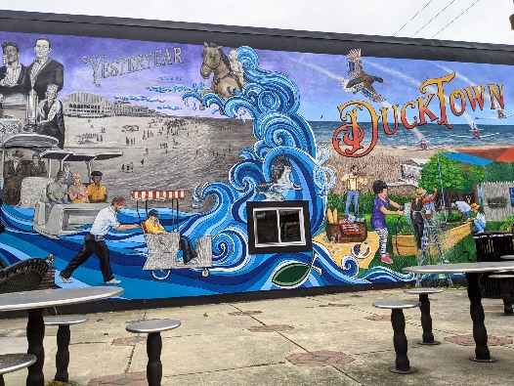
Ducktown, Rolling Into
The Future
Above: Photograph of Ducktown, Rolling
Into The Future
The Noyes Arts Garage of Stockton University, in partnership with the Ducktown Neighborhood Association, commissioned local artist Susan Daly to produce, “Ducktown, rolling Into the Future.” The mural is located at Barbera Fish Market in Ducktown, Atlantic City, New Jersey.

Susan Daly:
Daly is a professional artist, children’s book illustrator, large mural creator, portrait artist and all around anything you want commission collaborator with a career that has spanned over 30 years. She describes her commissions as “collaborations” because, “the process truly is a combination of my client’s theme, then they allow me to create the image as I see it.” She designs and paints her work herself and has many styles from hyper realistic to more graphic faux mosaic. In this mural displayed in Ducktown, she combines both styles. She specializes in painting predominantly in Atlantic City, New Jersey, and Charleston, South Carolina. Day’s work can be found at casinos, restaurants, and private residencies. Susan Daly is best known for her large scale work which is typically created on large canvases and installed like wallpaper. Her choice to create her work on canvas allows the murals to be removed, outlasting the durability of sheetrock.

Daly says, “The theme presented to me was, illustrating past icons of the Ducktown district (old time photo grays) and transitioning into the present (full vibrant color). Vintage rolling chairs styles parade along a stain glass wave (St. Michael’s Church- symbol of the fish swimming) into the present including beach concerts, fine dining (picnic basket), community garden, The Noyes Arts Garage of Stockton University, Outlet’s shopping, and The Air Show. Let’s not forget Mr. Peanut where you can take a photo, pretend sitting on the bench. I added a little Trompe L’ oeil style imagery in there too. See if you can find it. For those unfamiliar, that means fool the eye or trickery.”
For more information on Susan Daly, please visit the following:
Artist Website: www.mastersmuralstudio.com

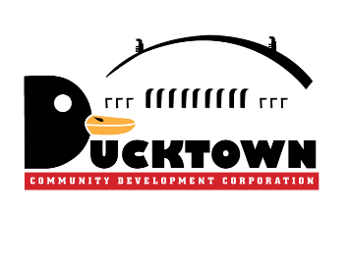
The Noyes Museum of Art of Stockton University · www.noyesmuseum.org · (609) 626-3420
The Noyes Arts Garage of Stockton University · www.artsgarageac.com · (609) 626-3805
Check us out on Facebook, Twitter, Instagram and YouTube.
