Education Guide September 28, 2018 – January 26, 2019

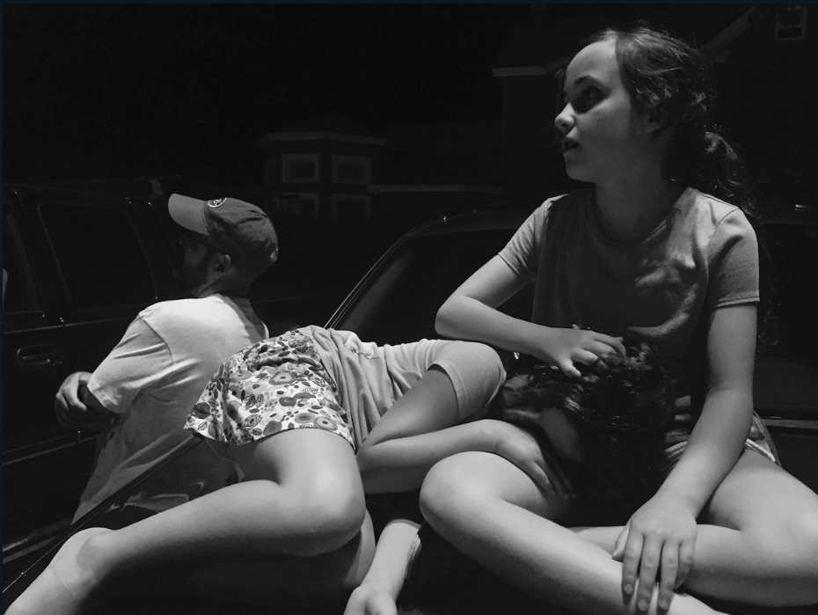
RAW 2018: Juried Photography Exhibition

Second Friday, October 12, 2018
6:00 – 8:00 pm
Free Opening Reception
Awards and Live Podcast by
Michael Chovan-Dalton, Juror

The Noyes Museum of Art of Stockton University presents RAW 2018, the fifth annual juried photography competition in which the top images have been selected for an exhibition at The Noyes Arts Garage of Stockton University in Atlantic City. The theme for this exhibition is "Light & Shadow: Form, Metaphor, and Culture.” Photographers considered this theme in several ways: as the formal use of light in photography, as a metaphor (personal, spiritual, psychological, etc.), or as a representation of cultural concerns (social and political).
Andrea Sauchelli, Crisscross, photograph

On the evening of Friday, October 12 from 6:00 to 8:00 pm, juror Michael Chovan-Dalton will announce the First, Second and Third Place prize winners for RAW 2018. Chovan-Dalton will follow this announcement with a live podcast direct from the Noyes Arts Garage, interviewing a selection of photographers on site.
JUROR: Michael Chovan-Dalton is a photographer, a professor and coordinator of Photography and Digital Imaging at Mercer County Community College in New Jersey, the JKC Photo Gallery Director, and he is the creator of the podcast RealPhotoShow.com. His podcast features artists with discussions about origins, influences, teaching, books, showing, tools, technology, and anything else that may come up in conversation. He was awarded a BFA from the School of Visual Arts in New York and an MFA from Columbia University.
http://chovandalton.com/ www.realphotoshow.com /http://www.mccc.edu/community_gallery_jkc.shtml

RAW 2018: Photography Exhibition – Exhibiting Photographers:
- Anolik, Mitchell: Iceland Waterfall, digital inkjet print
- Badia, Chuck: No Parking, archival pigment
- Benfer, Amy: Visitor, digital photograph
- Booth, Jessica: Monotony, digital photograph
- Bumgarner, Travis: Lights-Out, print
- Cohen, Edan: Lifting the Cheese, digital photograph
- Davis, Nastassia: Boys Don’t Cry, digital photograph
- Dimaculangan, Marco: Untitled, photograph
- Dixon, G. Matthew: Reflection, photograph
- Donnelly, Kohl: Untitled, photograph
- Fleming, Sherman: Invisible n00se: Bearing Witness at Underground Railroad Museum, digital photograph
- Gaboardi, Carlo: The Dress, photograph
- Giatropoulos, John: Forbidden Forest, digital inkjet print
- Girardello, Michelle: Remnants II, digital photograph
- Hess, Kenneth: Shadow Tree, digital photograph
- Jackson, Kayla: In the Shadows, digital photograph
- Jean, Megan: The Girl, digital photograph
- Kelly-Gutjahr, Barbara: After Party Girl, photograph on canvas
- Lauther, Todd: Man in Water (Weightless), archival inkjet print
- Lugara, Joe: v433 – Struck Series, digital print
- Malhotra, Cintia: City in the Sky, pigment print
- Ori, Nancy: The Kitchen, archival inkjet photograph
- Orlowicz, Jessica: Caretaker, digital photograph
- Orme, Abigail, The Remnants, 35mm enlargement
- Osborne, Mike: Monopoly Series, inkjet print
- Pasqualicchio, Suzanne: Quest for Health, digital photograph
- Petrella, Alissa: Fence, digital photograph
- Pollman, Sarah: Shelton Fireworks, Fair Play, SC, archival inkjet print from 4x5 negative
- Powell, Alan: Headsplash, archival inkjet
- Rackowski, Danielle: Transcendence, #3, digital photograph
- Rago, Dani: Untitled Wall #4, Giclée print
- Reed, Glynnis: Plato’s Cave - Shadow Series, archival inkjet print
- Rico Sanchez, Hernando: Interlude II, digital photograph
- Sauchelli, Andrea: Crisscross, digital photograph
- Schoenleber, Kristopher: Boat House, digital photograph
- Sen, Tania: Flight of the Baool Spirit - III,
photograph
- Sharp, Keith: Side II, archival pigment print
- Shofed, C.a.: Malcolm-Less, photograph
- Smith, Wilson: Unseen, digital photograph
- Spadola, Michael: Follow Me, photograph
- Spencer, Grace: Cuban Fighter, digital photographic print
- Svalbonas, Krista: Eichstatt 2, layered laser cut pigment print
- Terrell, Loraine: Batsto Village, pigment print
- Trip Morrow, Olivia: Hanging Diamond No. 5, digital print photograph
- Troeller, Linda & Lentzou Selzer, Christina: Ab Inferno Ad Vida, inkjet print
- Troeller, Lothar: Chelsea Hotel Window View, inkjet print
- Viggiano, John: Aerostat Surveillance, print
- Vostrikov, Kuzma & Song, Ajuan: In the Ocean of Saturn, archival pigment print
- Werhun, Anthony: 1968 Part 2, photograph
- Whitebay, Diane: Whiteout, digital photograph
- Wray, Lindsay: Hub of Humanity, photograph
- Young, Summer: See Through, digital photograph
- Ziebel, Peter: 102416, archival pigment print

Check us out on Facebook, Twitter, Instagram and YouTube
The Noyes Museum of Art of Stockton University: www.noyesmuseum.org (609) 626-3420
The Noyes Arts Garage of Stockton University: www.artsgarageac.com (609) 626-3805
Funding for the Noyes Museum of Art is provided in part by the NJ State Council on the Arts/Department of State, a partner agency of the National Endowment for the Arts, and the Geraldine R. Dodge Foundation.

