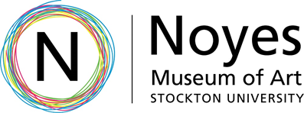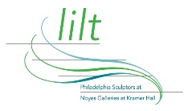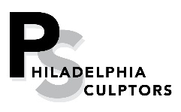

Education Guide October 20, 2022 – January 20, 2023

lilt
Opening Reception:
Third Thursday,
October 20th, 2022, 5 – 7 pm

The Noyes Museum of Art of Stockton University, in collaboration with Philadelphia Sculptors. presents Lilt, a new, vibrant exhibition of contemporary sculpture at Stockton Kramer Hall in Hammonton, NJ. The exhibition makes use of elements of light, movement, and layered forms to embrace the viewer in a meditative, almost other-worldly ambience. The 25 artworks by 16 artists that were selected by jurors TK Smith and Brittany Webb reflect the artists’ creative responses to the word “lilt.”

“In this sculpture exhibition, lilt is made tangible through the meticulous manipulation of material into both abstract and figural forms. The artists responding to the open call challenged us to approach the term in new ways, to expansively consider the ephemeral and immaterial, and the definition of sculpture itself.”

The resulting exhibition is a coalescence of sculptures and multi-media installations that appear to be dipping and swaying in an imagined dance with one another. Woven into the visual presentation is a quieter acknowledgement of themes of harmony, new life, and spiritual connection that informs the work of some of the artists. While others respond to current and impending world crises and disasters, there is still a reference to our shared humanity, suggesting it as a source of hope.

About Philadelphia Sculptors: philasculptors.org
Philadelphia Sculptors is the only professional organization of sculptors in the Philadelphia region. Incorporated in 1997, its mission is to promote contemporary sculpture and serve as an advocate for sculptors by expanding public awareness of the role and value of sculpture within our culture. Since its inception, it has organized numerous exhibitions at both traditional and non-traditional venues and has sponsored programs, conferences, workshops, and performances. Membership is open to all.

Lilt Jurors' Statement

TK Smith & Brittany Webb, Ph.D.

Lilt is a characteristic rising and falling of voice, a pleasant gentle accent, a spirited or rhythmic tune or flow. It can erupt from the mouth, as an expression of sound, language or song, or from the heart, as an attempt to capture fleeting feelings of cheer. In this sculpture exhibition, lilt is made tangible through the meticulous manipulation of material into both abstract and figural forms. The artists responding to the open call challenged us to approach the term in new ways, to expansively consider the ephemeral and immaterial, and the definition of sculpture itself.

Lilt offers a brief snapshot of local sculptors and multimedia artists that find buoyancy in weighty materials like metal, wood, stone and glass, who work with natural and found materials, and artists who sculpt forms from color, light, and sound. This exhibition includes pedestal-based sculptures, sprawling, site specific installations that capture a sense of movement and rhythm, projected video and rotating kinetic objects. We intend a display featuring an array of multigenerational contemporary artists of considerable skill, working within and against conventional sculpture to create a sense of levity, in narrative, tone, or sculptural gesture.

We are grateful to Darla Jackson, Leslie Kaufman and The Philadelphia Sculptors and to Michael Cagno and his team at The Noyes Museum of Art of Stockton University for the opportunity to jury this exhibition. We look forward to the thoughtful conversations it will inspire both in and beyond the galleries.

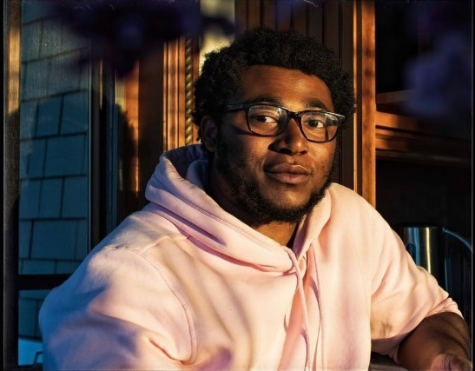
Jurors
TK Smith is a Philadelphia-based curator, writer, and cultural historian. His curatorial projects include Roland Ayers: Calligraphy of Dreams, the 2021 Atlanta Biennial exhibition Virtual Remains, and Zipporah Camille Thompson: Looming Chaos. His writing has been published in Art in America, the Monument Lab Bulletin, and ART PAPERS, where he is a contributing editor. In 2021 he was the invited inaugural writer at the Vashon Artist Residency, and he was a 2022 recipient of an Andy Warhol Writers Grant. Currently, Smith is a doctoral student in the History of American Civilization program at the University of Delaware, where he researches art, material culture, and the built environment. "
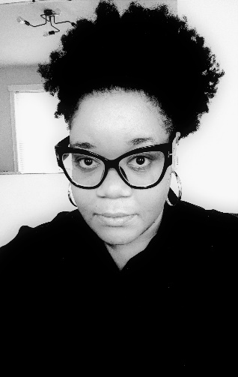
Brittany Webb is the Evelyn and Will Kaplan Curator of Twentieth-Century Art and the John Rhoden Collection at the Pennsylvania Academy of the Fine Arts (PAFA), where she is responsible for the Museum’s collections, exhibitions, and programs of 20th century art. Prior to joining PAFA, Dr. Webb was a member of the curatorial staff of the African American Museum in Philadelphia. Dr. Webb holds a Ph.D. in Anthropology from Temple University and a B.A. in Political Science from the University of Southern California.

Artist Biographies:

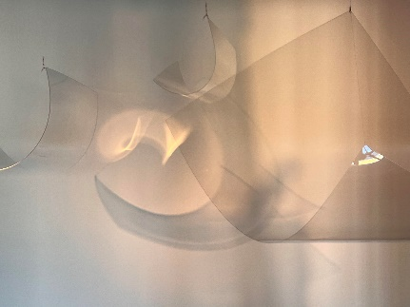
Jessica Beckwith, Philadelphia, PA
Jessica Beckwith began her career in theater, studying at the National Shakespeare Conservatory in NYC and performing and directing regionally. Driven by a desire to encompass the viewer, she began exploring new ways of using media and light through immersive installations. In her work she explores the subtle unity between the observer and observed and ways in which perception and thought shape reality.

Neill Catangay, Philadelphia, PA
Neill Catangay (b. 1993) is a Filipino interdisciplinary artist born and raised on Guam now living and working in Philadelphia, PA. Catangay received his MFA at the Pennsylvania Academy of the Fine Arts and his BA at the University of Guam. Catangay explores the ironic relationships between found objects and personal memory, using materiality, color, and Lo-fi methods to create objects, images, and environments of particular context. He uses the physical connections of this process along with influences from pop/subculture to explore themes of absurdity, the abject, colonialism, consumerism, and post-humanism.

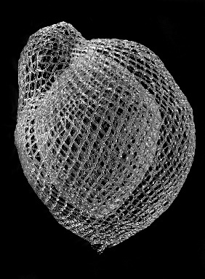
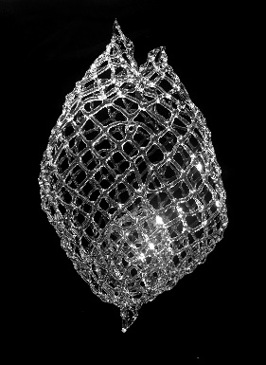
Marcy Chevali, Jackson Heights, NY
Marcy Chevali is a visual artist with an MFA from the Maine College of Art. She has shown work in galleries and artists’ spaces including Villa Terrace Decorative Arts Museum, Queens Museum of Art, AIR Gallery, Gallery Aferro, and Jamaica Center for Arts and Learning, and with organizations such as South Asian Women’s Creative Collective, Hudson Valley Center for Contemporary Art, ABC No Rio, Project for an Empty Space, 4heads and Peculiar Works Projects. She was awarded an artist grant from the Queens Art Fund in 2015. In 2017 she was a fellow at the Edward Albee Foundation.

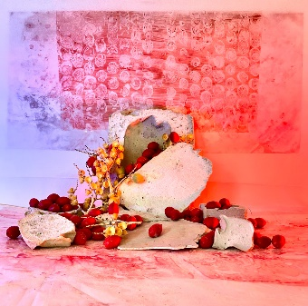
Kristen Jordan, Kapaau, HI
Kristen Jordan is a Hawai’i based artist with a focus on creating environmentally motivated art as meditative practice. She received an MFA from Pennsylvania Academy of the Fine Arts in Philadelphia, PA in 2014, a Post-Baccalaureate Certificate from Maryland Institute College of Art, and her BFA from Kansas State University. Her work has been featured in solo, group and juried shows across the United States.

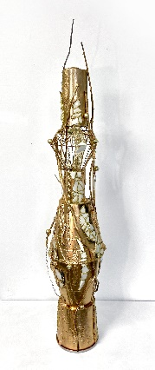
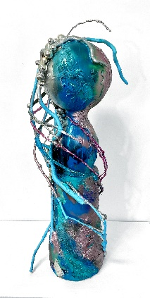
Aaron Kalinay, Philadelphia, PA
Aaron Kalinay is inspired by moods and feelings influenced by context and environment and how that is expressed in line, color, and composition into structured abstraction in painting and sculpture. Aaron grew up in a small town in northeastern Pennsylvania and now lives in Philadelphia. He is a member of the Da Vinci Art Alliance in Philadelphia and has showed in numerous Pennsylvania, New Jersey and New York group shows. He attended Temple University and Holy Family University, taught English in Vietnam, and has been teaching art for the School District of Philadelphia since 2008, making art and traveling whenever possible.

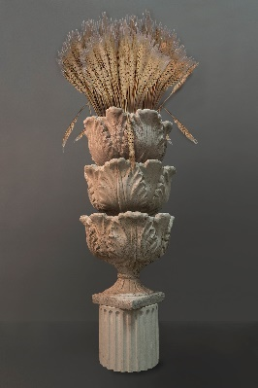
Virginia Maksymowicz, Philadelphia, PA
Virginia Maksymowicz is a mixed-media installation artist based in Philadelphia, PA. She received a BA in Fine Arts from Brooklyn College, and an MFA from UC San Diego. She has exhibited at the Franklin Furnace, Alternative Museum, Elizabeth Foundation and Grey Gallery in New York, and in college, university and nonprofit galleries throughout the US and abroad. In recent years, her work has followed a complex visual trail of architectural and figurative elements. She is interested in the metaphorical implications of the human body, especially the female body, when tied to place: buildings, fountains and other structures.

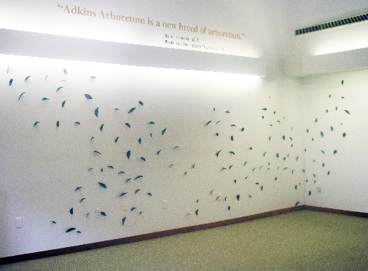
Elizabeth Miller McCue, Yardley, PA
Elizabeth Miller McCue works thematically and predominantly in unique bronze castings ranging in scale from gallery works to corporate, public and site-specific commissions. She studied Southeast Asian archaeology at Vassar College and on the graduate level at the School of Oriental and African Studies, University of London, England. Her studio training was in New York at the Art Students League and the New York Studio School. She has had ten solo exhibitions and participated in over 85 group exhibitions in the US.

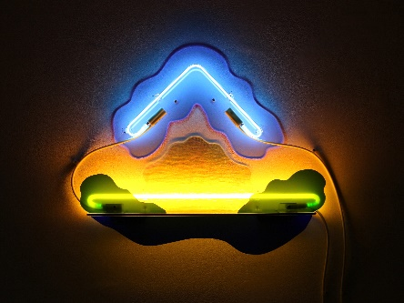
Lisa E. Nanni, Yardley, PA
Lisa E. Nanni is a sculptor and installation artist whose work uses color and abstraction to visualize wavelengths of light, and energy flow. Lisa received her M.F.A. from the Mason Gross School of the Arts at Rutgers in 1980, after which she lived and worked in Williamsburg, Brooklyn from 1981-2004. Her work has been exhibited at venues including the Abington Art Center, The State Museum of Pennsylvania, Manhattanville College, Westbeth Gallery, Islip Art Museum and Governors Island. In addition, she has participated in residency programs at PS 122 Project Studio Award Space, and the Vermont Studio Center. She also created a site-specific, neon installation on the Project Wall at the New Arts Program, Kutztown, PA. Lisa currently lives and works in Bucks County, PA.

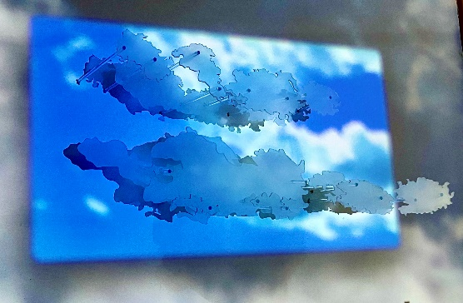
Joanna Platt, Philadelphia, PA
Joanna Platt received her BFA from Mason Gross School of the Arts, her MFA from the University of the Arts, and is currently working on a PhD in Art History at Tyler School of Art and Architecture. Joanna balances an active studio practice with research into visual culture, the mediations of technology, the representation of labor in art, and the economics of art and production. Exhibitions of Joanna’s work have included the Rosenwald-Wolf Gallery, Tiger Strikes Asteroid, and the Independence Seaport Museum in Philadelphia, The Hunterdon Museum of Art in Clinton NJ, Artist Run at the Satellite Art Fair in Miami, Galeria Nacional in San Jose, Costa Rica, and SoHo 20, NY, NY. She is currently an assistant professor in the art department at Camden County College.

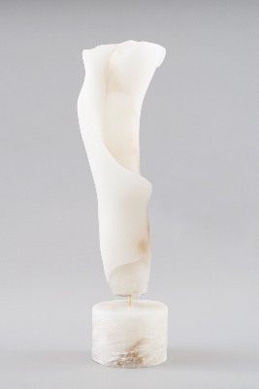
Sherry Rossini, Holland, PA
Sherry Rossini is an Italian American artist currently working in marble, bronze, installation, and performance. Residing in Pennsylvania, Sherry also spends time working in Carrara and Pietrasanta, Italy. Sherry’s recent work is an examination of combining meditation with carving marble stone sculptures. Education includes a Master of Fine Art from The Pennsylvania Academy of the Fine Arts, 2022, a Master of Education, and Bachelor of Fine Art from Moore College of Art and Design, Philadelphia.

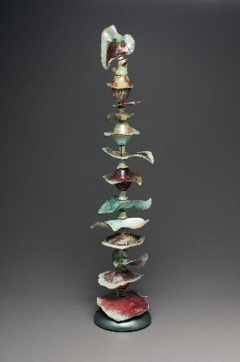
Helge Speth, Wenonah, NJ
During her youth in Europe, Helge loved working creatively with her hands. Her first professional choice was to become a physician and she completed medical school. Helge relocated to the US with her family and obtained a degree in Art Education. Then, while teaching art full-time for 25 years, she took courses in clay, fiber and metal at Tyler School of Art, the University of the Arts, the Clay Studio, Perkins Art Center, and the Main Line Art Center. During summers, she studied at Penland, Haystack and Peters Valley. Helge has received five Awards of Excellence at Perkins and has shown her work at places such as Rowan College, DaVinci Art Alliance in Philadelphia, Center for American Craft in Lancaster, and Philadelphia City Hall.

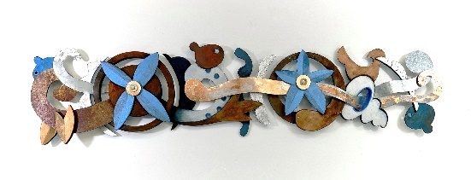
Kathleen Spicer, Norristown, PA
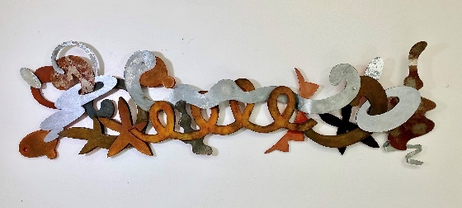
Kathleen Spicer studied art at the Philadelphia College of Art (now University of the Arts) and Parsons School of Design. Her painted wood sculptures, mixed media sculptures, and relief paintings are dynamic and lively constructions often inspired by nature. Kathleen’s work may defy traditional definitions of sculptures, as it often seems to embrace other possibilities for a sculpted or constructed object –they may be colorful drawings in space or meditations on moving, choreographed shapes. She has received many significant commissions, including New York Department of Cultural Affairs, the Fort Shelby Hotel, in Detroit MI, and the City of Chicago Police Department, among others. She continues to teach, curate and lecture about art, as well as creating work at all times.

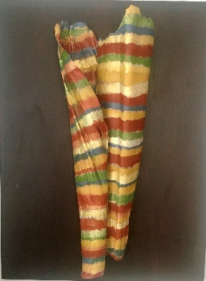
Pamela Tudor, Philadelphia, PA
Pamela Tudor is a painter and maker of mixed media shadow boxes and sculptures. Her expressive paintings and sculptures investigate concerns about the destruction and beauty of our home planet. After receiving an M.A. in Applied Psychology from New York University, she went to art school for four years. Pamela has shown at the Pennsylvania Academy of Fine Arts, the Fairmount Waterworks, the Marriott at the Philadelphia Navy Yard, the Noyes Museum in Oceanville, NJ, the El Paso Museum of Art, and the Emerging Collector Gallery in NYC. Her work is in private collections in NY, NJ, Philadelphia, Miami, and Los Angeles.

Nina Valdera, Atco, NJ
Nina Valdera is a recent graduate of Vermont College of Fine Arts in Montpelier, Vermont where she was awarded her MFA in Visual Arts. She received her BFA in Art Education from Moore College of Art and Design in Philadelphia, Pennsylvania. She currently resides in South Jersey, but was a long time native of Philadelphia. Nina’s light sculpture Synchronicity was featured on billboards throughout the greater Philadelphia area for Moore College of Art and Design’s rebrand. Her works have also been shown in group exhibitions, including Atria Center City Gallery, Da Vinci Art Alliance, The Clay Studio, Philadelphia Sculptors, Spillway Collective, Wilma W. Daniels Gallery, and Wharton Esherick Museum. Nina continues to work at Nemours Children’s Health as a Medical Assistant.

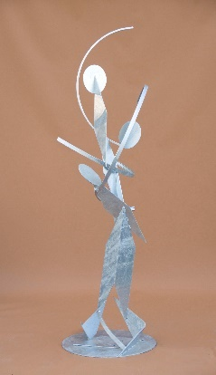
Michelle Vara, Wilton, NY
November of 2019, Michelle Vara opened a gallery with guest curators to organize unique contemporary art shows. She felt a calling to create just for the sake of art which led her on a journey to finish her MFA from University of Plymouth in England and travel extensively. She is interested in the politics of the universal consciousness and tethered to the lineage of the Abstract Expressionists; it engages with Jungian ideals that there is a shared consciousness tapped into and revealed through the viewers' engagement with abstracted color and form as her work is not bound in one medium or style, but joins multiple platforms of material, and processes that she believes necessary for subject engagement.

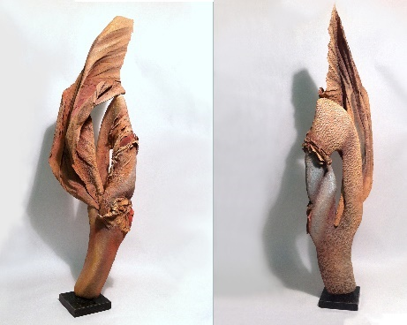
Georgette Veeder, Adamstown, PA
Georgette Veeder spent her early childhood travelling around Europe with her family. Settling in New Jersey she went to Montclair University where she received a degree in Fine Arts. After a teaching stint, she returned for advance studies at the Pennsylvania Academy of the Fine Arts where she studied sculpture and printmaking and developed an interest in making her own paper. Her works have been widely exhibited in galleries and represented in many public and private collections. Recognition at the local and national level include the Pennsylvania Governor’s award and publication in the Fiber Arts Design Book 7, Best of American Sculpture Artist, Vol II 2010. Last year her cast paper wall sculpture, Sassy, was purchased for the Pennsylvania Academy of the Fine Arts permanent collection. Georgette now lives and works with her artist-husband in Berks County, PA, on a small farm where she has four sheep, two goats and 12 rescued cats.

For more information on Philadelphia Sculptors, please visit the following:
Website: philasculptors.org
Facebook: Philadelphia Sculptors
Instagram: philasculptors
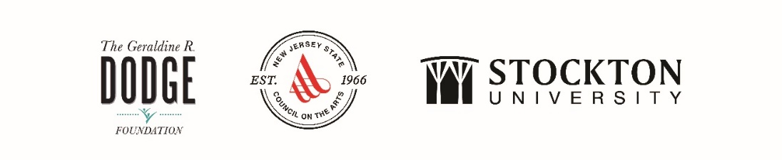
The Noyes Museum of Art of Stockton University · http://www.noyesmuseum.org · (609) 626-3420
The Noyes Arts Garage of Stockton University · www.artsgarageac.com · (609) 626-3805
Check us out on Facebook, Twitter, Instagram and YouTube.

