Education Guide November 14, 2022 – January 2, 2023

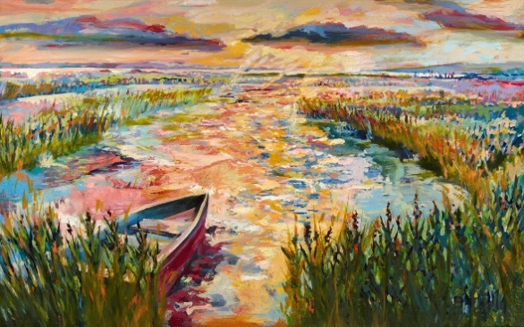
Linette Childs
Linette Childs, ‘Shadows of Two’, oil on canvas

Exhibition Overview:
Linette Childs is the owner of Wills Creek Solution LTD, based in Cape May Court House, New Jersey, a company specializing in classic techniques of oil painting, generating graphic design, webpage development and corporate logos. Linette is also a Senior Designer, at Van Note-Harvey, Associates, a Civil Engineering & Land Surveying Firm headquartered in Princeton. Over the years she has exhibited throughout the United States.

Her career started early. Each year, one graduating high school senior is chosen to receive a Prestigious National Award, selected from an applicant pool from every State in the United States. Known as the U.S. Presidential Scholar in the Arts Award for recognizing Artistic Talent in multiple categories, Linette Childs won for the Category of Fine Arts. After exhibiting in the coffers of Washington DC’s executive offices of the White House, and in a solo presence on stage at the Kennedy Center, attributing her original oil painting titled "Old Angler's Inn" to featuring the painting and presenting to the Secretary of Education, Richard Riley, in 1995, Linette's work exhibited internationally. From Italy, France, to New York’s bustling city of Manhattan, Washington D.C, Baltimore, to the local area of Avalon, Stone Harbor, Absecon, Millville and Cape May Linette has become a staple of the art community. Recently, Linette exhibited as a “Strobe Signature Artist” at Millville’s Riverfront Renaissance Center for the Arts. She gives back to the community by supporting families grappling with children’s cancer. AtlantiCare has Linette’s work as part of their permanent collection for the Healing Arts Program.

Linette is active in with Annual Plein-air Painting events held by Absecon Cultural Arts Alliance (ACAA), local juried art exhibits and virtual shows held by Avalon Performing Arts Council (APAC), the Artist’s Guild of the Cape’s Juried Mad Batter Show, Noyes Arts Garage of Stockton University Exhibit in Atlantic City, Atlantic Cape Community College Plein-Air Competition Show sponsored by Atlantic County Parks Association and Cape May’s SOMA New Art Gallery “Solo Show” titled ‘Souls in Still Motion’. Just this past October, she displayed and sold for auction, a Limited-Edition Print of her Plein-air Oil Painting "Golden Meadow at Faunce Landing", on display at an exclusive event, at the Hard Rock Hotel & Casino in Atlantic City, NJ.

Her love for painting started when she was in grade school, having sold her first original oil painting, at the age of 14. Her interests in Painting allowed her the opportunity to study and receive a Bachelor of Arts (B.A.) in Interior Architecture & Design, from a FIDER accredited program at Maryland Institute College of Art, where she was awarded the Talheim Scholarship. Ms. Childs has received numerous awards including, Avalon Performing 2015 Best of Show Award, Avalon, New Jersey; SJ Marina and Saltwater Café Art & Carafes. In November 2014, Linette returned to her native state of Maryland, with over 60 new original oil paintings and has her first solo gallery show, titled “Esoteric Dreams” at the ‘Yellow Barn Gallery’, in Glen Echo, Maryland.

For more information on Linette Childs, please visit the following:
https://fineartamerica.com/profiles/linette-childs
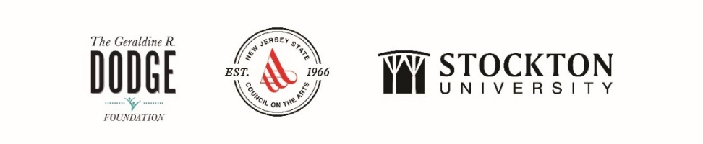
The Noyes Museum of Art of Stockton University · http://www.noyesmuseum.org · (609) 626-3420
The Noyes Arts Garage of Stockton University · www.artsgarageac.com · (609) 626-3805
Check us out on Facebook, Twitter, Instagram and YouTube.

