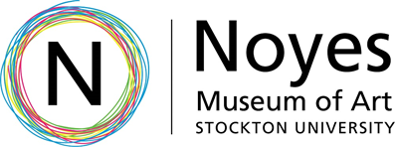

Education Guide October 8, 2022 - January 8, 2023

Noyes Artist Members Exhibition: 2022
Opening Reception:
October 14, 2022
6:00 – 8:00 PM

Exhibition Overview:
What is the Artist Members Program? The Noyes Museum of Art of Stockton University has established an artist membership program for regional artists. This membership is for professional artists working in any medium. Exhibition opportunities at the Noyes Museum and its satellite facilities in Atlantic City, Hammonton and/or at Seaview Resort in Galloway, participation in programs and events, listing on Noyes Museum website with link and access to artist resources are some of the benefits of acceptance in this program.

The Artist Membership is a highly competitive membership awarded to an established professional artist in any medium whose original work exemplifies the highest caliber of artistic standards, who has previously exhibited in museums and/or galleries, and/or teaches in their respective medium. The Noyes Artist Members Exhibition: 2022 is the newest rendition of this yearly tradition, highlighting the artists in our membership program.

Artist Biographies:
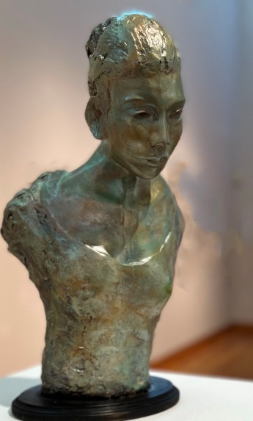
Robert Baum, Giselle, stoneware clay, $1,500
Robert Baum- Ocean City, NJ
www.artpal.com/rbaum215
Baum has been working directly from nature since sketching scenes on his grandfather's farm as a boy in Cross Keys, N.J. He returned to his love for art while in the Air Force during the Vietnam War. And after his tour of duty, he finished his bachelor's and master's degrees in education and art education at Rowan University. His career has spanned teaching as well as writing and editing for several magazines, all the while maintaining his gallery presence. He has now retired from teaching and journalism in order to paint and sculpt full time. Baum and his wife Carolyn make their home in Ocean City, NJ, and the gulf-coast community of Dunedin, Florida. Baum is an of several museums and organizations, as well as actively exhibiting his work across the East coast.

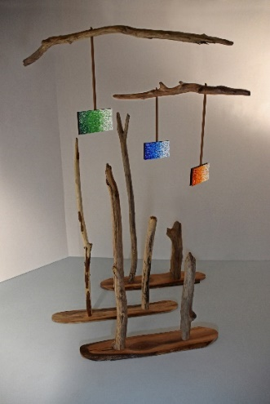
t.a. hahn- Middletown, DE
www.ta-design.com
t.a. hahn, Avians for Calder, mixed media, $875
Sculptor and abstract oil painter t.a. hahn demonstrates his love for harmony in nature, and the essence of wild birds in their natural habitat. Creating has always given the artist a sense of peace. A proud alumnus of the University of the Arts, his main career focus was as an art and design director in the advertising and marketing areas. His true passion has been creating fine art, and has exhibited his works locally, regionally, and nationally.

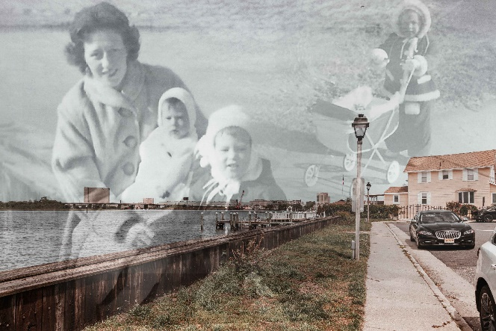
Christina Marie Klein – Atlantic City, NJ
www.christinamariekleinartist.com
Instagram: @christina_marie_klein_artist
Facebook: @ChristinaMarieKleinArtist
Christina Marie Klein, My Mother’s Mother, Past Meets Present, digital mixed media, Not For Sale
Christina Marie Walley is an interdisciplinary artist based out of Atlantic City, New Jersey. Walley graduated from Roger Williams University in 2010 with a Bachelor of Arts Majoring in Psychology and Double Minoring in Architecture & Visual Arts. After taking some time off from her studies Walley pursued her true passion of Visual Arts and received her Master of Fine Arts from San Francisco Art Institute in 2016. Since graduating, Walley works as a Professional Photographer, Adjunct Professor and Artist here in Atlantic City, New Jersey.

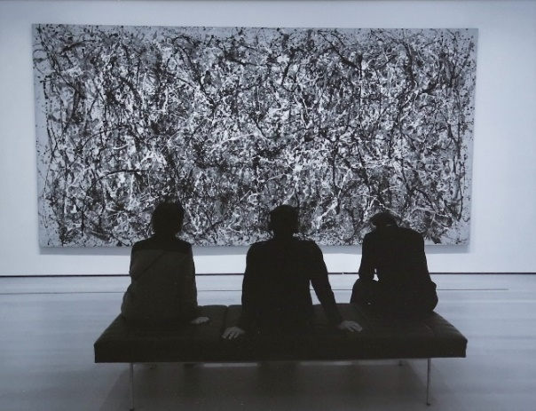
Dennis Loughlin – Galloway, NJ
www.stayfocusedphoto.club/dennis-loughlin
Dennis Loughlin, Attraction to Abstraction,
photograph, $150
Photographer Dennis Loughlin has sharpened his focus on photography through a variety of courses and workshops over the years, including graduate study at New Jersey City University, workshops at The Pixel Place in Moorestown, the Nikon School, the Stay Focused Photo Club at Stockton University, and even the Noyes Museum of Art of Stockton University. A 1988 recipient of the New Jersey Governor’s Award for Excellence in Teaching, Dennis frequently used his photos of historic sites in his role as a social studies teacher. In the last decade he has expanded his photographic interests as an unofficial photographer for his sons’ Springsteen tribute band “The E Street Shuffle.”
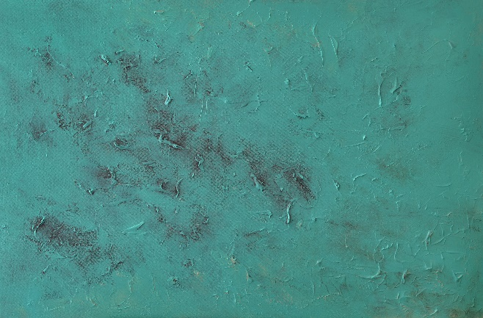
Joe Lugara- Linden, NJ
www.joelugara.com
Instagram: @joelugara
Facebook: @joelugara1art
Joe Lugara, The Fragile Ones (Aqua 1), acrylic, $900
Joe Lugara creates drawings, paintings, and photographs that depict odd objects, inexplicable phenomena, and fantastic dreamscapes. As a young filmmaker, he wanted to make horror films, built on the visual style and imagination of classic horror films of the ‘30s and ‘40s. The spirit of these films has remained in his work and have given the sense that the world is a mysteriously appealing, yet perilous place, to be approached with caution. Lugara’s goal is to disarm the viewer’s reason.

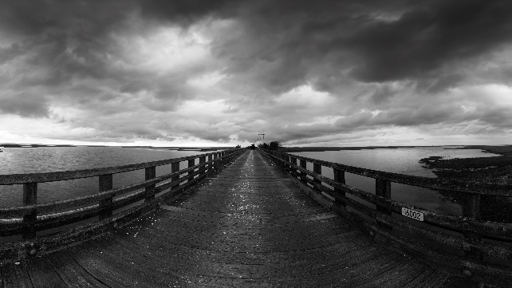
George Mattei- Little Egg Harbor, NJ
www.georgemattei.com
George Mattei, Rain Clouds on 7 Bridges Road,
photography on metal, $525
Instagram: @georgemattei444
Professional photographer George Mattei is a New Jersey native. His most frequent and major subjects are landscapes and seascapes and takes several exposures to create a wide range of tones. He also focuses in advertising and works with clientele in the medical, industrial, and food industries. His past clients include Siemens, Lipton, Nabisco, Berkley College, and currently Helen Hayes Hospital. In addition, his fine art photography has been included in numerous group shows across the tri-state area. Mattei earned a BFA at the School of Visual Arts in New York City.

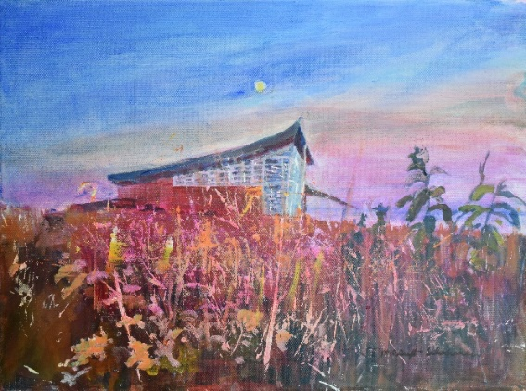
Lucretia E. McGuff-Silverman- Roosevelt, NJ
www.mcguffsilverman.com
Lucretia McGuff-Silverman, Heritage Center in Moonlight, acrylic, $500
Lucretia E. McGuff-Silverman, has always been interested in painting landscapes and people. These paintings are an exploration of a specific place and time. She grew up in San Antonio, Texas, and then moved to the East Coast since 1990. With that move her paintings changed, making her aware of how profoundly she is affected by the unique character of her environment. In her paintings she uses a play of color and light to portray her emotional reaction to these environments. Lucretia has an MFA in Oil Painting, from American University. The three works submitted to this show are landscapes inspired by her “Artist in Residence” at Homestead National Historical Park, during September 2021.

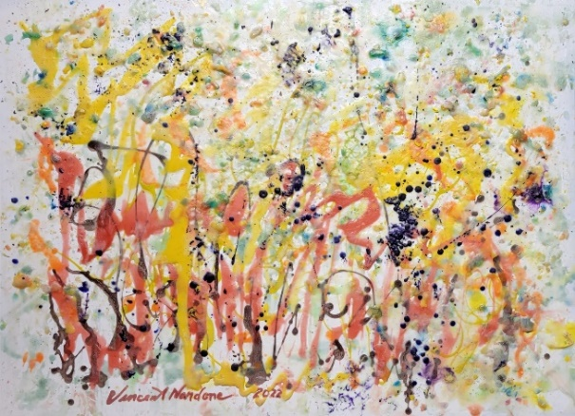
Vincent Nardone- Brick, NJ
www.vincentnardone.com
Vincent Nardone, Bay Wilderness,
encaustic on metal, $3,600
His career began as a child where he trained in studio arts at the Newark School of Fine Arts & Industrial Arts. Later, he graduated his BFA from Montclair University and his MFA from the University of California. Nardone’s career as an art educator spanned 30 years, teaching as an art specialist in public schools of South Orange and Maplewood, NJ. He has shown his work in exhibitions both nationally and internationally in exhibitions. His works as a visionary expressionist utilizes applying a multi-disciplinary approach through material exploration, abstractions, and gestural movement with both color and texture.

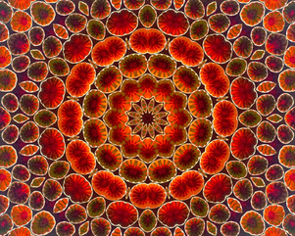
Carol Nussbaum- Short Hills, NJ
www.carolnussbaum.com
Carol Nussbaum, Art Basel Wall Flowers, photography based digital art printed
on metal, $420
Instagram: @carolnussbaum
Facebook: @carolnussbaumphotography
Carol Nussbaum creates mandalas from a variety of photographic subjects, ranging from bicycle handles to tulips. She weaves together these elements from her travels and trips to bring about a mood or movement to her experiences which is timeless. Her mandalas are inspired by how they are structured around a unifying center that represents both wholeness and the universe. Nussbaum followed a successful career of advertising in NYC to exhibiting her mandalas and photographs around the US, earning awards from juried shows.

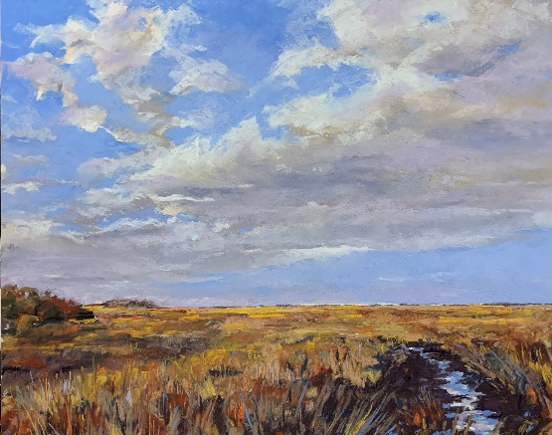
Bill Parker- Absecon, NJ
www.billparkerartist.com
Bill Parker, Sacred Grounds, pastel, $1,300
Instagram: @billparkervisualarts
Facebook: @bill.parker.9822
Having spent all his summers on the Jersey Shore, Bill’s memories of the churning surf, observing the tides rise and fall, seeing the shifting sand create new landscapes across the beaches and back bays shaped a huge part of who he is and how he sees the world. His working career in marketing and advertising in the greater Atlantic City area has now come full circle to allow him to become a full-time pastel painter. As a creative director, Bill was responsible for developing marketing campaigns, crafting meaningful messages, and producing impactful images. When viewing his work, Bill strives for there to be a conscious balance of color and texture that allows each person to create their own interpretation. I like telling a story through my paintings. Bill hopes that his paintings expose you to our special place here in the southern shores of New Jersey.

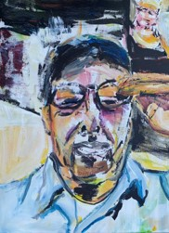
Suzanne Pasqualicchio – Forked River, NJ
www.suzannepasqualicchio.com
Suzanne Pasqualicchio, Zoom Zoom, acrylic on canvas, $1,100
Instagram: @spasqualicchio
During the years prior to becoming an art educator and advocate, Pasqualicchio was part of a team of female mural painters creating numerous public and private large-scale murals over a ten-year period from 2000-2010. While working professionally as a muralist, Suzanne continued to develop her personal body of work, primarily consisting of oil on canvas. Suzanne completed a BA in Art Education from the College of New Jersey in 2006, then a MA in Teaching from Ashford University in 2010. All of her paintings are essentially self-portraits, with her work providing a record of her existence and relationships in this life. It involves the personal discovery and the quieting of a nostalgic desire to hold on. Thus, through her art, the introspective becomes shared.

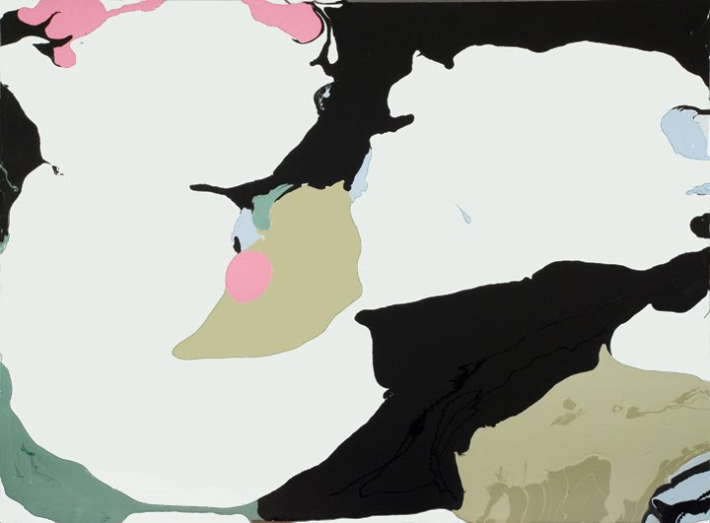
Vincent Romaniello – Union City, NJ
www.vincentromaniello.com
Instagram: @vincentromaniello
Vincent Romaniello, No. 1001, mixed media, $2,150
After working in San Francisco for 14 years for publications including The Bay Guardian and Metro Magazine, Vincent moved to New York City where he concentrated his studies on painting at the School of Visual Arts and the New York Academy. In 2008, Sage Projects was founded by Vincent and in early 2009 the group opened a co-op gallery operated by its members. The space was a repurposed retail store that was on loan for an eight-month period during which time over 200 under-recognized artists exhibited their work. He has exhibited his artwork nationally and internationally, and has been the recipient of several honors including awards and residencies across the region. Vincent Romaniello’s work focuses on two things: magic and mechanics.

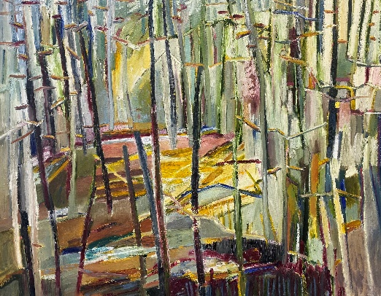
Andrea Sauchelli- Manahawkin, NJ
www.andreasauchelli.com
Instagram: @andreasauchelli
Facebook: @sauchelliandrea
Andrea Sauchelli, Prism, oil on canvas, $1,800
Artist Andrea Sauchelli mostly works in oils, but also incorporates pencil and oil pastels, and occasionally experiments with India ink on mylar. She is drawn to the richness and intensity of colors and creating bold, expressive brushstrokes. Her greatest influence is her father, and her parent’s fondness of both traditional and contemporary styles, which sparked her creativity and enjoyment of art. Born in Columbus, Ohio, she received her BFA from Rochester Institute of Technology in New York.

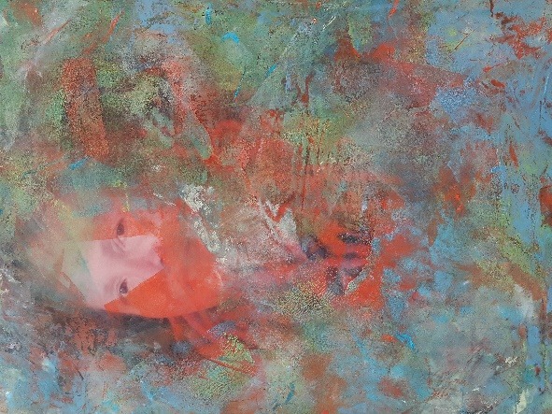
Beatrice Y. Stenta – North Wildwood, NJ
www.strobenj.org/beatrice-y-stenta/
Beatrice Y. Stenta, Myself under the Layers, mixed media, $1,200
Beatrice Y. Stenta describes her work as intuitive and influenced not just by the surroundings but also by her mind and heart. She graduated with her BFA from Youngstown State University. Her work has been shown in numerous exhibitions throughout South Jersey, including being accepted into the AtlantiCare of Healing Art and Art Space at Nashville North Studio in Linden, NJ. In 2016, Beatrice moved to North Wildwood and begin to concentrate on mixed media. As a mixed media artist, she strives to compose stories, visually telling viewers about the environment, the political world, despair, and hope. Her process begins with citrus solvent-soaked National Geographic Pages, the ink breaks down and blurs the image in the long saturation process, forming mystical and worldly atmosphere, then adding charcoal, pencil marks, textured paper, acrylics, and cold wax & oils layered over the top, creating patterns and depth.

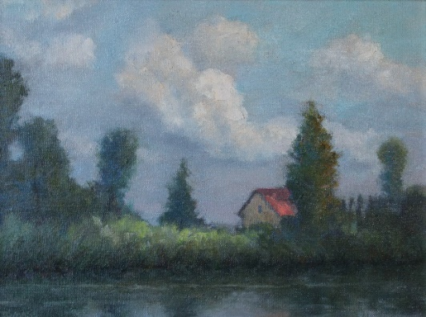
Diane Tomash, Amongst the Trees,
oil on linen, $750
Diane Tomash- Little Egg Harbor, NJ
Diane Tomash is a graduate of the Pennsylvania Academy of the Fine Arts and the Newark School of Fine and Industrial Art. She has taught art throughout southern New Jersey for several years, most recently at the Noyes Museum of Art of Stockton University. Her works are held in private collections throughout the United States, London, the Print Archives of the Pennsylvania Academy of the Fine Arts, and the Rohm and Haas Corporation in Philadelphia.

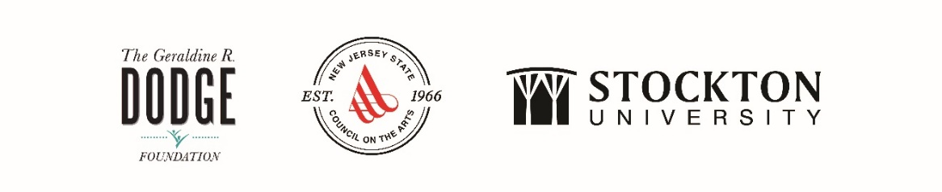
The Noyes Museum of Art of Stockton University · http://www.noyesmuseum.org · (609) 626-3420 The Noyes Arts Garage of Stockton University · www.artsgarageac.com · (609) 626-3805
Check us out on Facebook, Twitter, Instagram and YouTube.

