**Summer 2022 Recap**

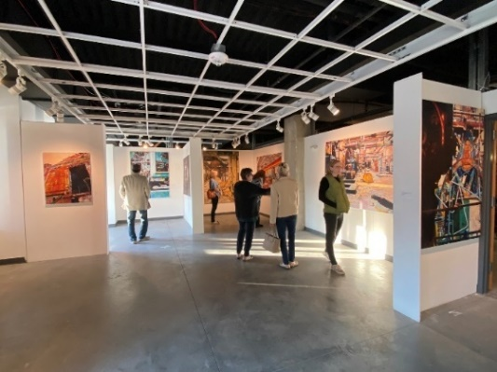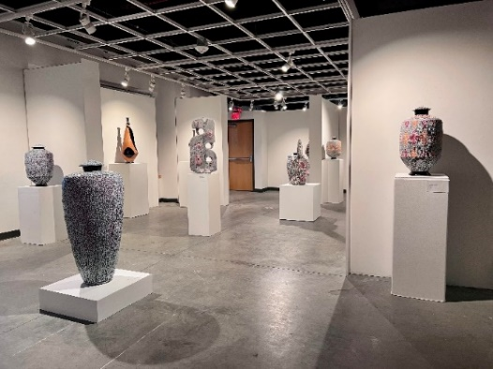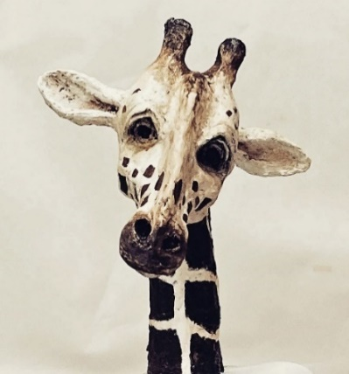*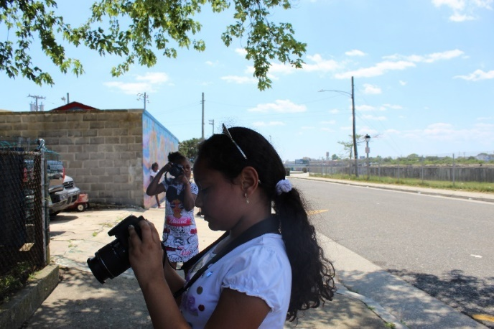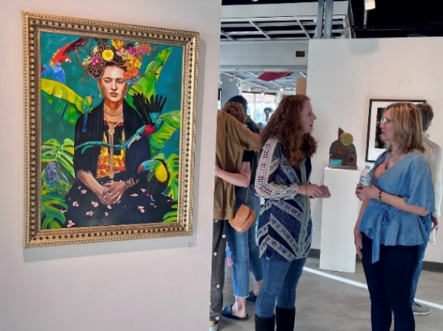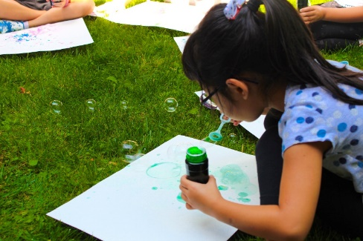

Oceanside II Family Success Center

Summer Camp, Galloway Campus

Morgan Craig

Skeff Thomas

Treacy Ziegler

AC Boys & Girls Club

Summer Teen Program

Multicultural Camp AC

ArtC Presents Clique21

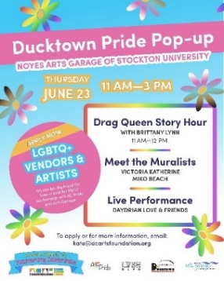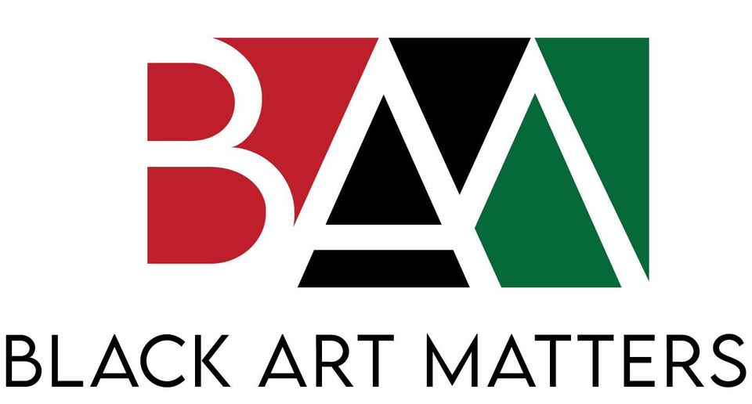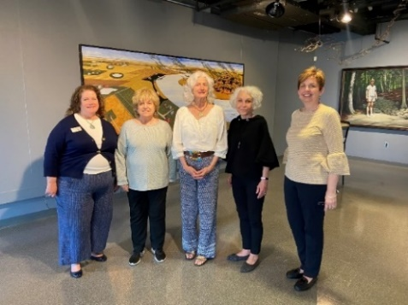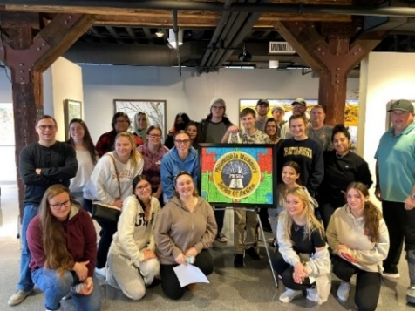

Landscapes of the Mind: Regional Center for Women in the Arts Exhibit

Ducktown Pride Pop-up

Black Art Matters Monthly Program

Artist Nick St. Clair,

Stockton Arts & Disability Class

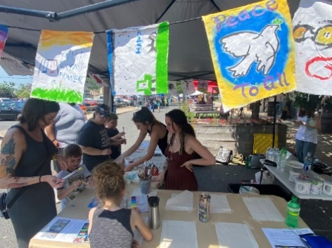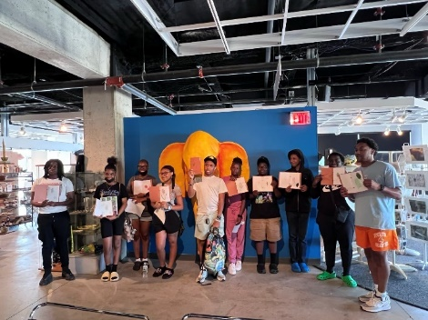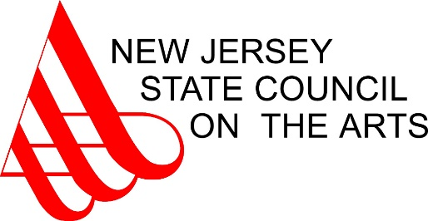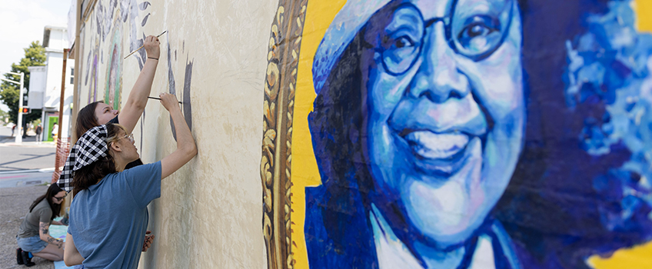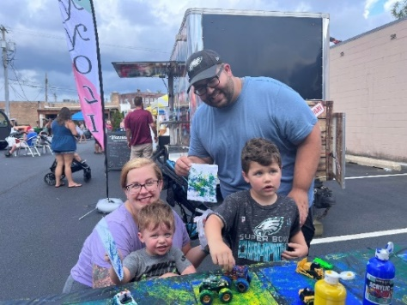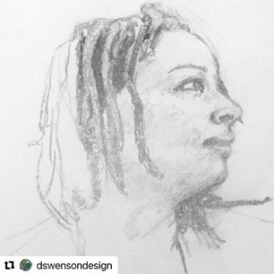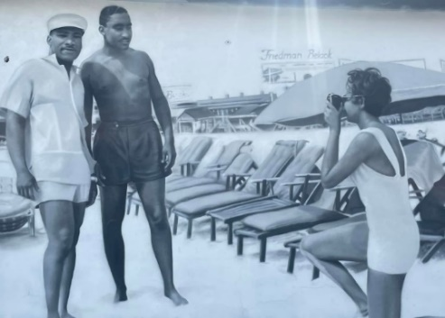

Light Color Painting Class Continuing Studies

Hammonton Arts & Music Festival

Nature Journal Workshop with Forsythe Wildlife Refuge

Hammonton Touch-A-Truck Fiesta

Civil Rights Wall of Fame Mural in AC

Education Trailblazers Mural in AC

Life Drawing Classes

Dodge $30,000 Grant

NJSCA $109,000 Grant